2.54: a) To average 4 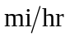, the total time for the twenty-mile ride must be five
hours, so the second ten miles must be covered in 3.75 hours, for an average of 2.7 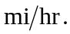 b) To average 12 , the second ten miles must be covered in 25 minutes and the average speed must be 24 c) After the first hour, only ten of the twenty miles have been covered, and 16 is not possible as the average speed.

